**Dynamic SQL with a DML Statement**

SELECT *FROM EMP2 ORDER BY EMP_ID;

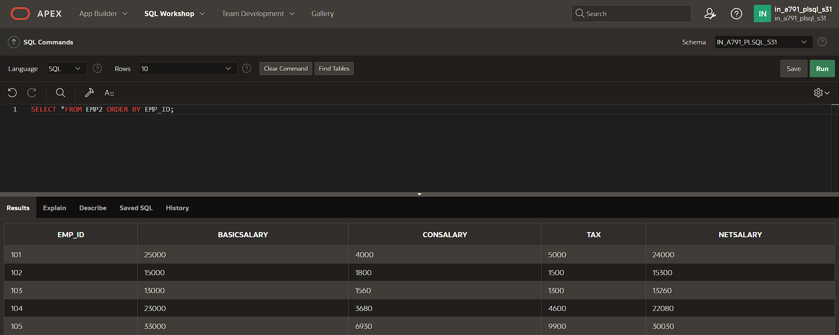

CREATE FUNCTION d_rows(p_table_name VARCHAR2)

RETURN NUMBER IS

BEGIN

EXECUTE IMMEDIATE 'DELETE FROM ' || p_table_name;

RETURN SQL%ROWCOUNT;

END;

/

DECLARE

LOCATION_ID NUMBER;

BEGIN

LOCATION_ID:= del_rows('EMP2');

DBMS_OUTPUT.PUT_LINE(LOCATION_ID || ' rows deleted.');

END;

/

